**Heroes of Pymoli Summary Report**

**James Milne – Unit 04 Pandas Challenge Homework**

**3 observations based upon the data (tables summarized below)**

1. Male players make up the majority of players (84% of the total number). These players also contributed nearly $2,000 to revenues (the highest total) in items they purchased.
2. Almost half (44.8%) of players are between the ages of 20-24.
3. The most popular (and most profitable) item is the “Final Critic” with a total purchase value of $59.99.

**Read in/display first 5 rows of the dataframe**

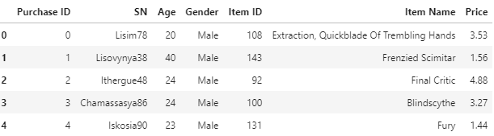

**Player count data**

Total number of players: 576

Total number of unique items: 179

Average Price of items: $3.05

Total number of purchases: 780

Total Revenue: $2,379.77

**Data Summary Table**



**Gender Demographics Table**

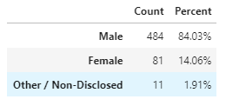

**Purchasing Analysis (Gender)**

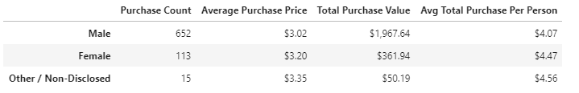

**Age Demographics**

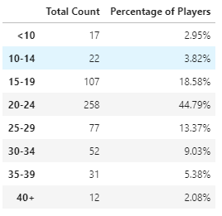

**Purchasing Demographics (Age)**

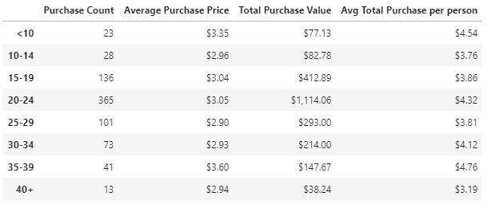

**Top Spenders**

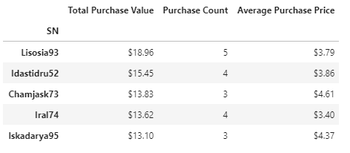

**Most Popular Items**

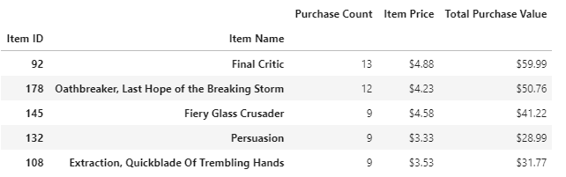

**Most Profitable items**

